**Lab Report-Ohm’s Law- Physics 1402 and 2426**

1. **Explanation of Issues:**
   1. Introduction/Hypothesis

This laboratory is relative to the application of Ohm’s Law. We will try to find the relationship between voltage, current and electrical resistance measured by conventional measuring instruments such as Voltmeter and Ammeter. We will collect and graphically represent data to investigate whether it is possible to establish a simple relation between the intensity passing through an ohmic dipole and the voltage at its terminals. We will carry out an electrical assembly which makes it possible at the same time to measure the intensity of the current passing through an ohmic dipole and the voltage at its terminals.

This experiment has three measurable quantities. First, the Voltage, represented by “**U”.** It is the difference between the electric potential between two points on a conductor wire.). the Voltage Is measured in volts and comes from various sources such as batteries. Second, the current, represented by “**I**”**.** It is measured in amperes. The Current is the movement of charged particles through a Conductive material between the voltage source and ground. The third measurable quantity is the Resistance, represented by “**R**”. It is the opposition exerted by a body to the passage of an electric current. The Resistance is measured in ohms.

* 1. Procedure

The first thing We did was to collect all the necessary material to carry out the assembly of the electric schema. we used the following equipment: a variable voltage generator, an ammeter, a voltmeter, and a resistor as below:

Secondly, with the aid of an ammeter and a voltmeter we started to measure respectively the intensity and the voltage. We connected the ammeter in series, and we connected the voltmeter in parallel.

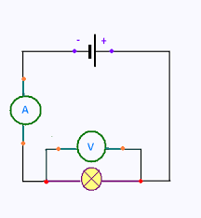

Thirdly, we carried out the results in two cases; The first case with a resistance of **11 ohms** and the second case with a resistance of **44 ohms.** We have thus obtained two tables containing the measurements of intensities and tensions **(see annex 1).**

Fourthly, we have used the collected data for both tables to apply the ohm’s law. We used the formula **R = V / I** to calculate the resistance as a function of the values of the intensity and the tension.

Fifthly, we have inserted in an excel table all the data collected and calculated in an excel table to obtain a curve similar to the curve below:

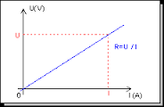

1. **Evidence/Data (Results)** 
   1. Representation

we carried out the results in two cases; The first case with a resistance of 11 ohms and the second case with a resistance of 44 ohms. We have thus obtained two tables containing the measurements of intensities and tensions. After inserting the collected data on an excel table, we obtained the following two curves:

Characteristic of Resistance 1:

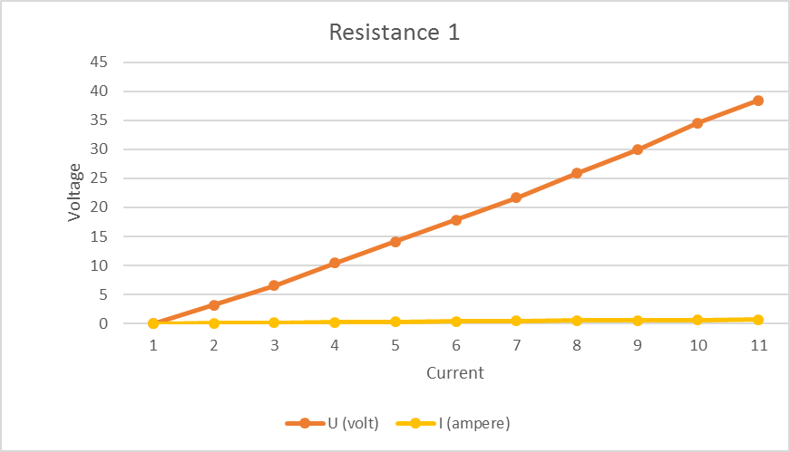

Characteristic of Resistance 2:

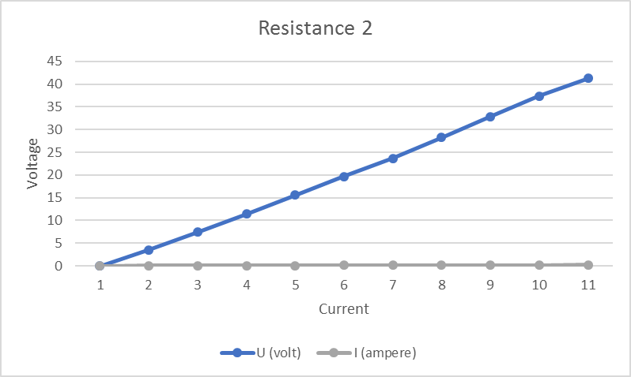

in both cases, the curves representing U (on the ordinate) as a function of the intensity I (in abscissa) gave us a straight line. The current-voltage characteristic of a dipole gives the variations of the voltage across the dipole as a function of the variations in the current flowing through it. This is written mathematically by **U = f (I)**. In these two cases, it has been verified that the initial data obtained are very close to the origin, so we can say that the formula **y=ax** is therefore respected. This correspond to **U=RI** (with y=U, a=R, and x=I).

We can then say that; the resistance of a fixed resistor corresponds to the slope of the line which defines the relationship between the voltage and the current. Another way of formulating this is to observe that the voltage which passes through the resistor is proportional to the current which passes through it. The resistance is simply the constant of proportionality between voltage and current.

Comparison of Resistance 1 and Resistance 2

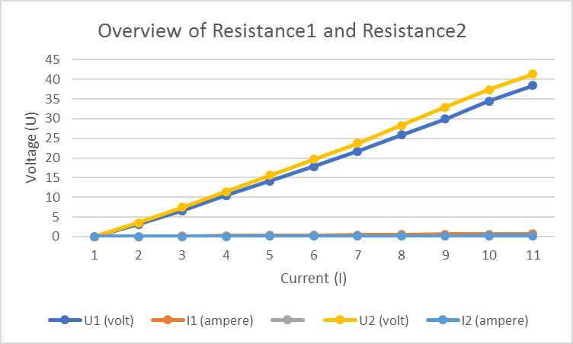

After observing the two curves, we found that the curve of Resistance 2 is above the curve of Resistance 1. This is normal because R2 > R1. The graphs indicate a linear relationship between voltage and intensity, so we can deduce a proportionality between these two quantities. Our measures are in accordance with ohm law.

* 1. Calculation

The relations formulated in the preceding paragraphs make it possible to write the following formula, synthesizing Ohm's law: Current = voltage / resistance, ↔ I **= U / R.** To calculate the value of the resistance when the value of the voltage and the current is known, we divide by **U** the two sides of the equality, we obtain:

I = U1 / R. → I/(U)=U/R /(U) → I/U=1/R → U/I=R→ **R=U/I**

**Case 1:** =

**Case 1:** R1=U1/I1

* + 1. Using the graph, find the value of Resistance R from the slope show your calculations.
    2. Using the graph, estimate the Current for which *V=3v*.
    3. Check this result by calculating from Ohm’s Law equation.

1. **Influence of Context and Assumptions/Student’s Position (CT)/Assumptions & Application (EQS):**
   1. Provide a brief comment on the strengths and weaknesses of the experiment.
   2. Discuss where and what could influence the accuracy of the data (sources of errors).
2. **Conclusions and Related Outcomes (CT)/Analysis & Communication (EQS) 30p**
   1. **Interpretation (EQS):** Was your hypothesis supported? Explain what your data shows and what your interpretation of the results is.
   2. Is your conclusion validated by the evidence/data or not? Why or why not?
   3. Is there anything surprising about your results?

First, if the resistance is increased in an electrical circuit, the current decreases. Indeed, it is then more difficult for electrons to circulate, the opposition being greater. Conversely, if the resistance is reduced, the current flow is facilitated.

On the other hand, if the fixed resistance is maintained, any increase in the voltage of the source will cause an increase in the current due to the increase in "pressure" on the electrons. Consequently, a decrease in the voltage will reduce the current flowing in the circuit.

The relations formulated in the preceding paragraphs make it possible to write the following formula, synthesizing Ohm's law:

**Current = voltage / resistance**, ↔ **I = U / R**.

To calculate the value of the current when the value of the voltage and the resistance is known, the formula of the Ohm law is applied in an integral way. On the other hand, to calculate the value of the voltage or the value of the resistance using this formula, the desired parameter must be isolated on one side of the equality. To do this, we must apply notions of algebra.

|  |  |
| --- | --- |
| If we multiply by **R** the two sides of the equality, we obtain: | If we divide by **U** the two sides of the equality, we obtain: |
| **I = U / R.**  **R** x **I=R** x **(U/R)**  **RI=U**  **U=RI** | **I = U / R.**  **I/(U)=U/R /(U)**  **I/U=1/R**  **U/I=R→ R=U/I** |